|  |  |
| --- | --- |
| Sony ZV-1  Máy ảnh Sony ZV-1 (Black) | Chính hãng  Sony ZV-1 01 Sony ZV-1 02 Sony ZV-1 03 Sony ZV-1 04 | **Featured information**  Sensor: 1 inch BSI CMOS  ISO range: 100 to 12800 (Extended: 64 to 25600)  Resolution: 20MP  Wireless connection: WiFi, bluetooth  Price: $ 750  **Specifications:**  Sensor Format  Are not  Resolution  20.1 Megapixels  Size photo  5472 x 3648  Image Proportions  1:1, 3:2, 4:3, 16:9  Sensor Type  CMOS  Image Format  JPEG, Raw  Anti-Vibration  Digital, Optical  Lens Mount  Are not |

**Overview:**

Featuring a 3.0" flip-out touchscreen and 3-way directional microphone perfect for front-facing recording, the Sony ZV-1 also has features that make Vlogging easier like Product Introduction Settings , Background Blur, Soft Skin Effect and Face Priority auto-exposure functions.



Despite its sleek and lightweight design, the Sony ZV-1 is still equipped with a large grip on the right for easy one-handed recording combined with a front notification light, a larger REC button on the top of the camera, and a hotshoe for attach accessories.

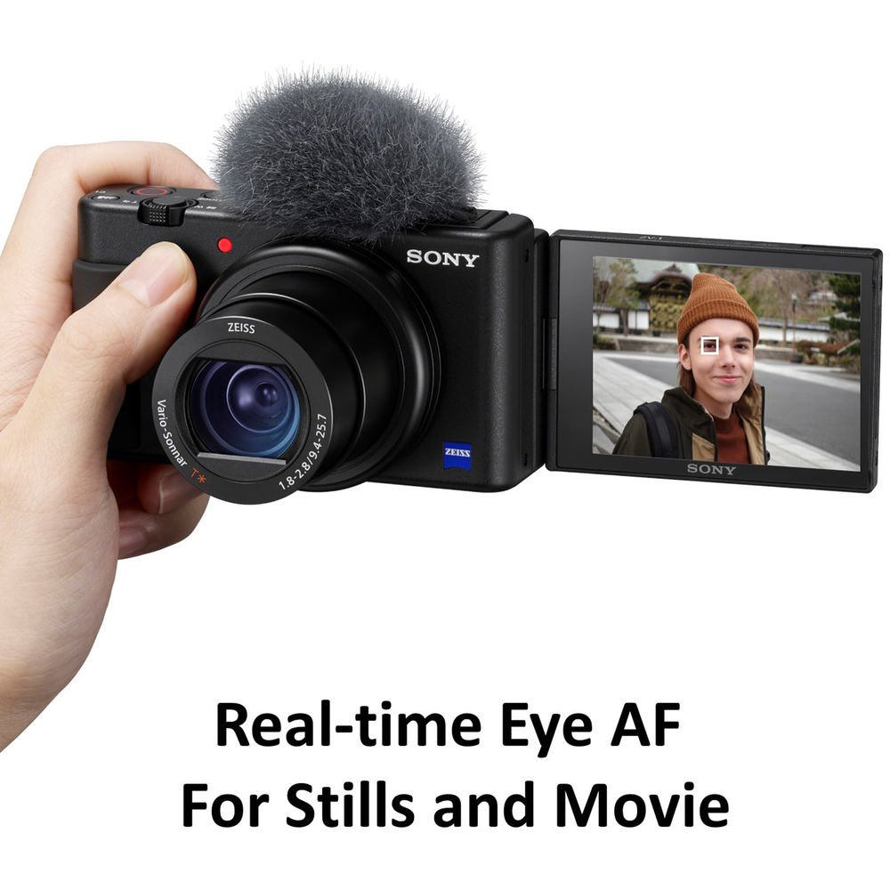

The camera is equipped with a ZEISS brand standard zoom lens with an impressive 24-70mm equivalent focal length, with a maximum aperture range of f/1.8-2.8, accompanied by Active image stabilization. SteadyShot helps stabilize footage and reduce camera shake for smoother footage.

